Keeping Active with Radwinter Recreation Ground
Village Sign-Spotting Challenge

I have taken photographs of 24 signs and notices around the village and cropped them. You need to use these photo clues to find the actual signs. When you have found the matching signs, you will be able find the letter required for each clue. All of the answers are single letters of the alphabet and some letters are repeated. When you have found all the letters, you need to form three words out of the 24 letters that relate to this challenge.

There are 24 signs, so 24 letters to find. They range from large road signs to tiny brass plates. All the signs can be found in the area circled on the attached Google map and some only be visible from one direction.

Letters need to be counted in usual reading fashion starting from the top and moving from left to right. Ignore any numbers, symbols, or gaps.

Below is an example. The answer to this example is not part of the challenge.

EXAMPLE CLUE - The letter you need is in 21st place.
The close-up photo should lead you to the clothes bank outside the school.
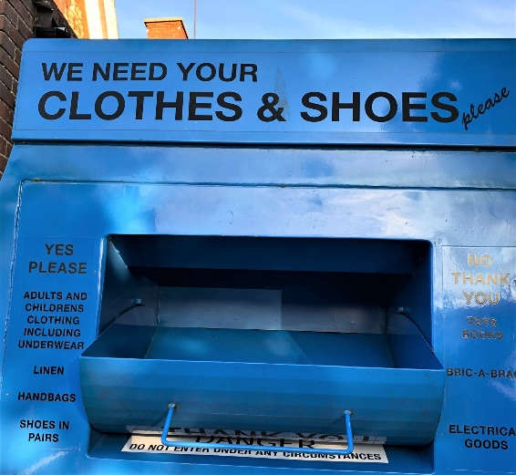
EXAMPLE ANSWER - You can now count along to find that the letter in 21st place ‘E’.

CLUE 1. The letter you need is in position 9
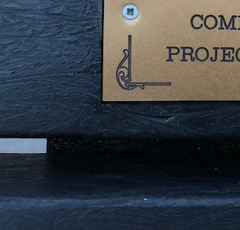

CLUE 2. The letter you need is in position 21
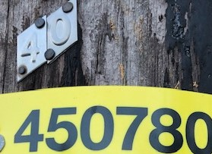

CLUE 3. The letter you need is in position 31
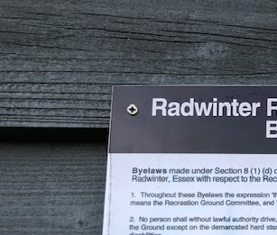

CLUE 4. The letter you need is in position 13
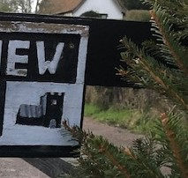

CLUE 5. The letter you need is in position 28
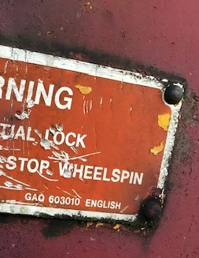

CLUE 6. The letter you need is in position 5
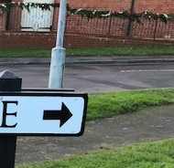

CLUE 7. The letter you need is in position 5
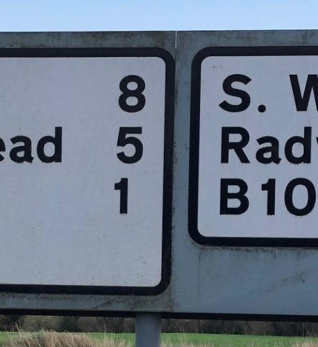

CLUE 8. The letter you need is in position 5
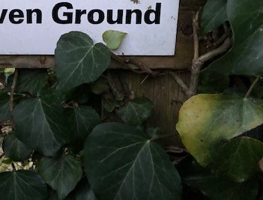
CLUE 9. The letter you need is in position 8
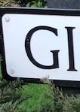

CLUE 10. The letter you need is in position 11
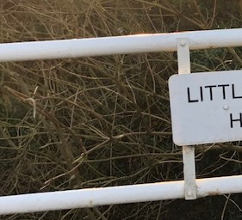

CLUE 11. The letter you need is in position 23
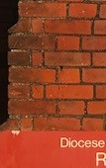

CLUE 12. The letter you need is in position 35
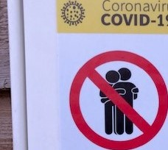
CLUE 13. The letter you need is in position 13
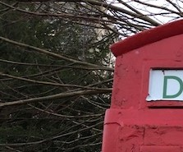

CLUE 14. The letter you need is in position 4
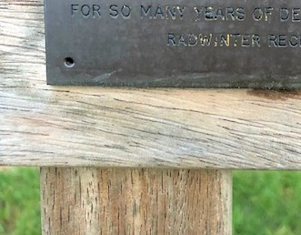

CLUE 15. The letter you need is in position 7
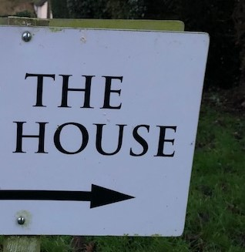

CLUE 16. The letter you need is in position 8
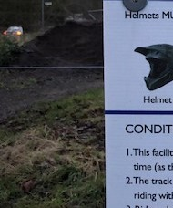

CLUE 17. The letter you need is in position 47
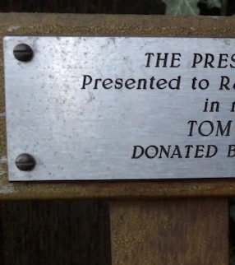

CLUE 18. The letter you need is in position 11
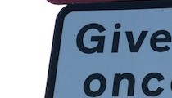

CLUE 19. The letter you need is in position 2
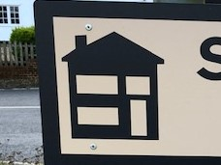

CLUE 20. The letter you need is in position 4
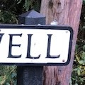
CLUE 21. The letter you need is in position 13
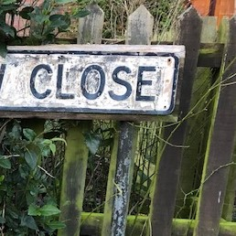

CLUE 22. The letter you need is in position 6
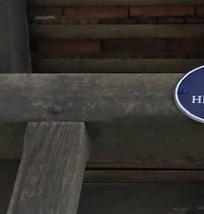

CLUE 23. The letter you need is in position 8
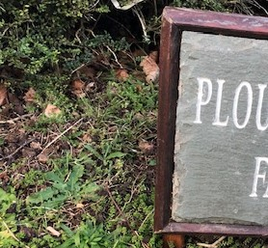

CLUE 24. The letter you need is in position 21
